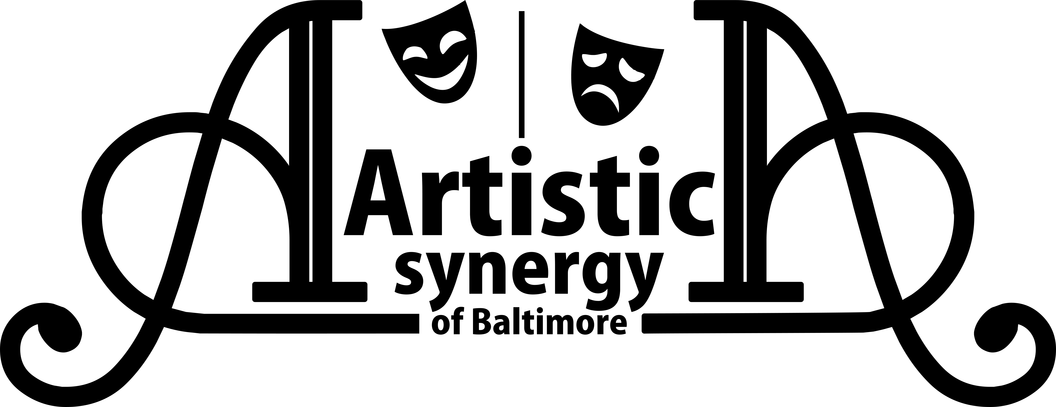
AUDITION FORM

Name:
(please print name as it will appear in all publicity, including the program)

Email Address:

Home Address:

Home Phone: Cell Phone:

Age: Gender Pronouns: Height:

Dance: Y N Styles:

Sing: Y N Range:

Please check ONE of the following:

I will accept any role.
I prefer the role of , but will accept any role.
I will accept only the role of .

Please note: Those who accept the roles of Jesus and John/Judas will exchange kisses on each cheek during the show. The director and team will work within your personal boundaries in all other aspects of touch and intimacy in the show. This is required for these two roles. If auditioning for either of these two roles, please initial here if you agree to this. ___________

Previous Theater Experience (you may attach a resume instead)
(Role/Staff/Crew, Production, Theater Name, and Location)

List SPECIAL TALENTS
(Examples: Playing an instrument, Juggling, Acrobatics, Puppetry, Up-close Magic, etc.)

List ALL CONFLICTS
Unless conflicts are listed on this sheet, you will be expected to be present at scheduled times.

Artistic Synergy of Baltimore is a consent based and trauma informed organization and all ensemble members will be led through intimacy and consent based practices to choreograph and block movements of the show. If you have questions regarding details or more information about these practices, please email us at artisticsynergybaltimore@gmail.com.
Initial here if you agree to our intimacy policy. _____________

For Production Staff Use Only

Vocal Range:
Reading:
Notes:

