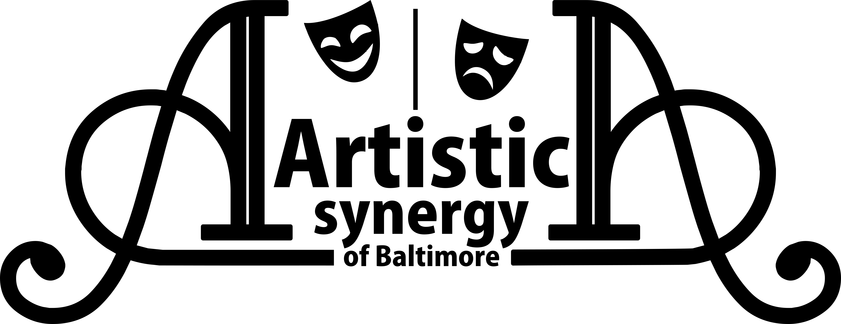
AUDITION FORM

Name:
(please print name as it will appear in all publicity, including the program)

Email Address:

Home Address:

Home Phone: Cell Phone:

Age: Gender Pronouns: Height:

Dance: Y N Styles:

Sing: Y N Range:

Please check ONE of the following:

I will accept any role.
I prefer the role of , but will accept any role.
I will accept only the role of .

Previous Theater Experience (you may attach a resume instead)
(Role/Staff/Crew, Production, Theater Name, and Location)

List SPECIAL TALENTS
(Examples: Playing an instrument, Juggling, Acrobatics, Puppetry, Up-close Magic, etc.)

List ALL CONFLICTS
Unless conflicts are listed on this sheet, you will be expected to be present at scheduled times.

Artistic Synergy of Baltimore is a consent based and trauma informed organization and all ensemble members will be led through intimacy and consent-based practices to choreograph and block movements of the show. If you have questions regarding details or more information about these practices, please email us at artisticsynergybaltimore@gmail.com.
Initial here if you agree to our intimacy policy. _____________

For Production Staff Use Only

Vocal Range:
Reading:
Notes:

